CS 255 System Design Document

UML Diagrams

UML Use Case Diagram
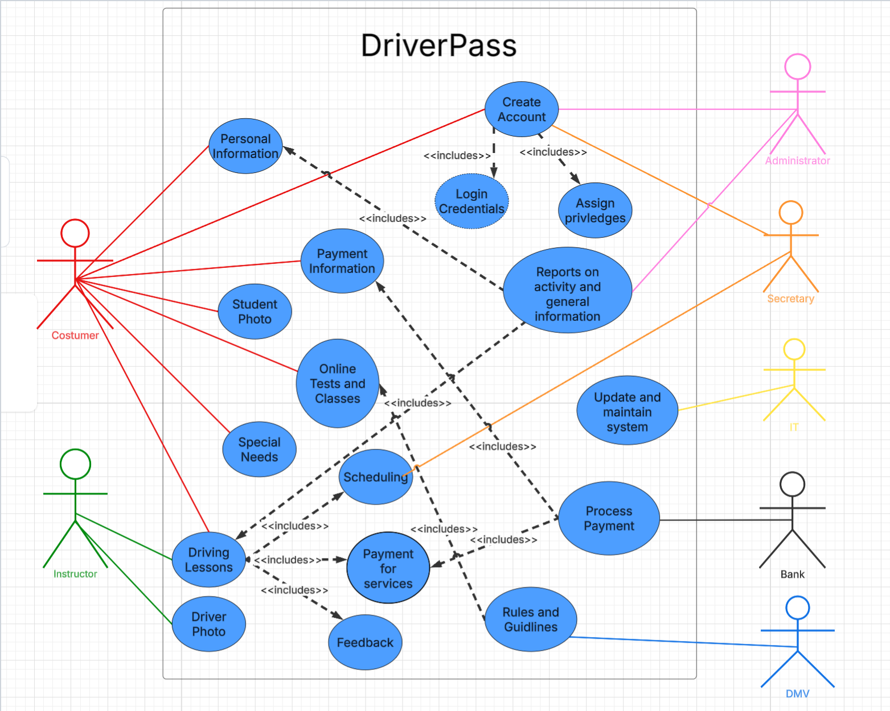

UML Activity Diagrams
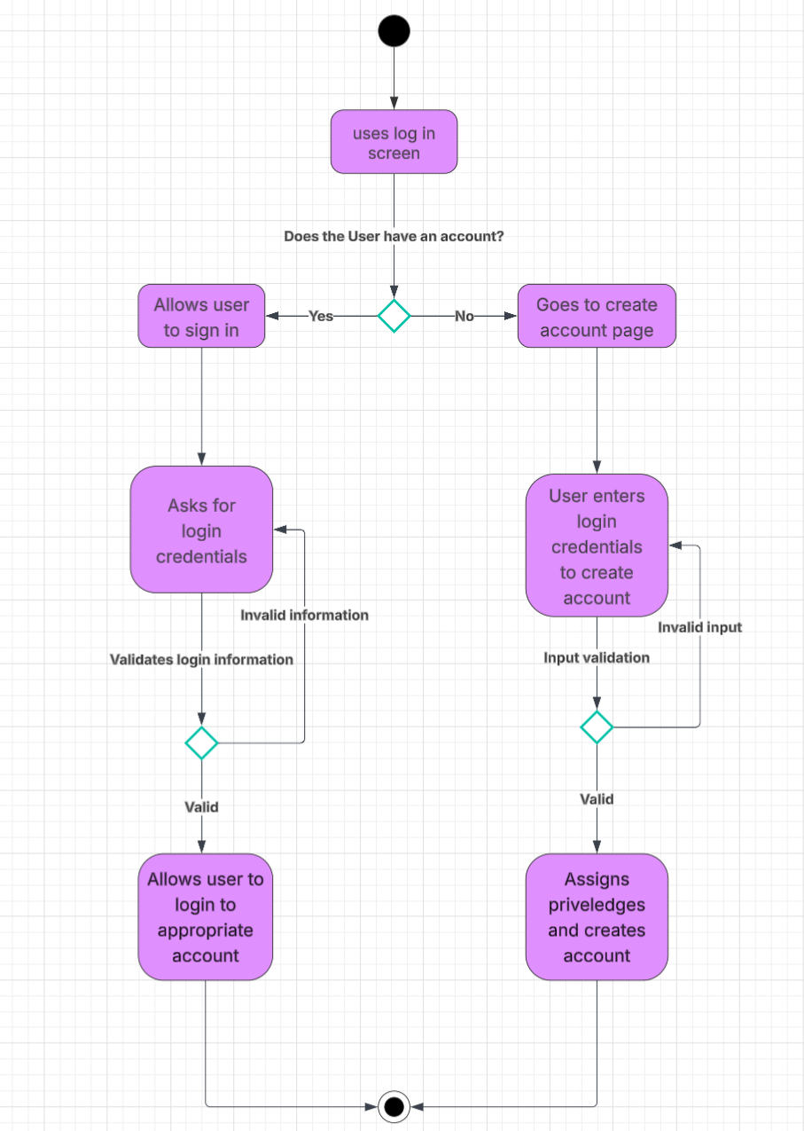

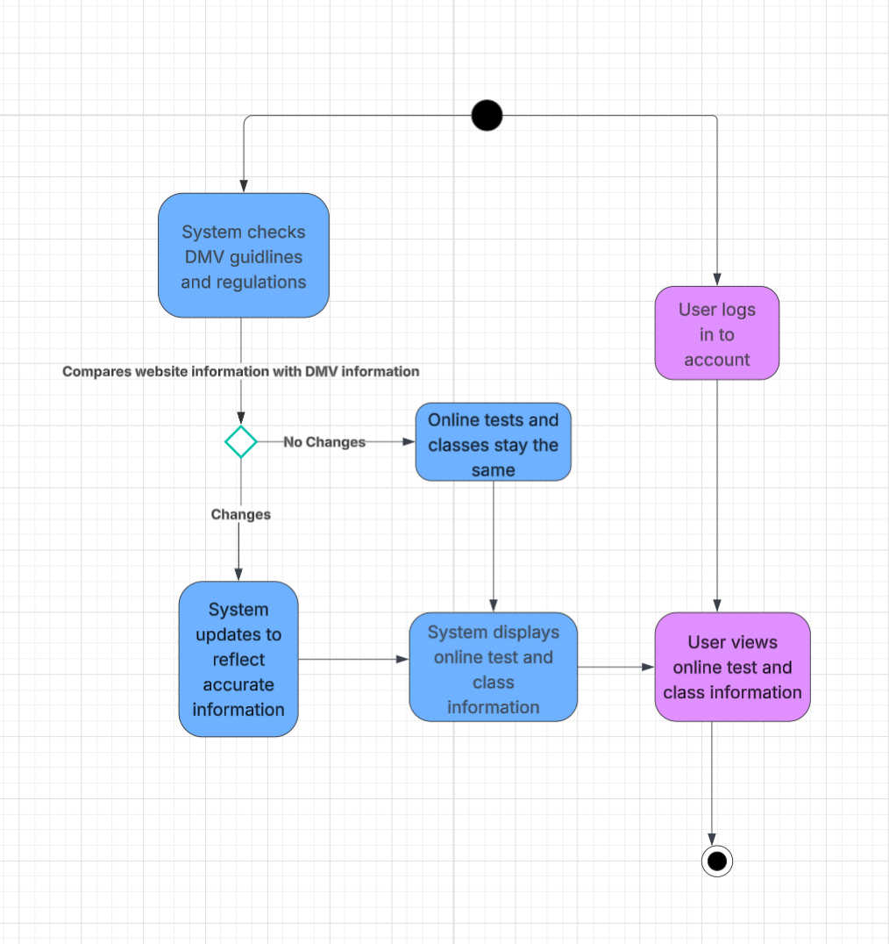

UML Sequence Diagram
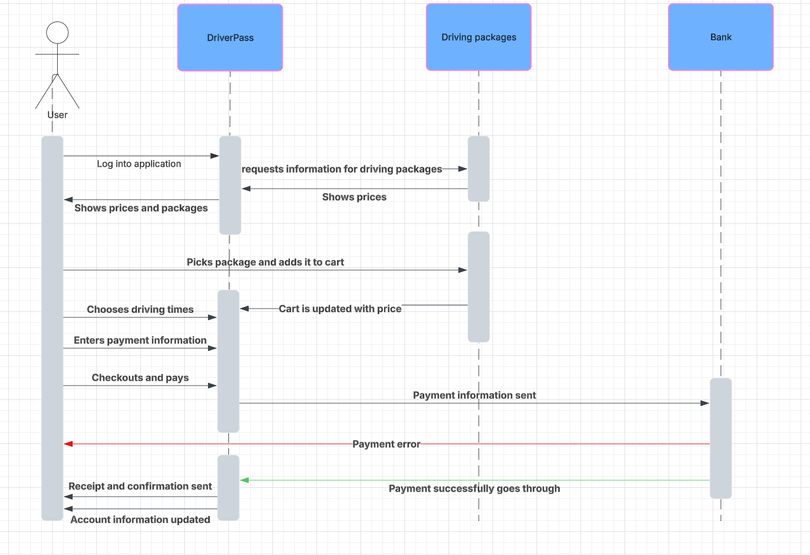

UML Class Diagram
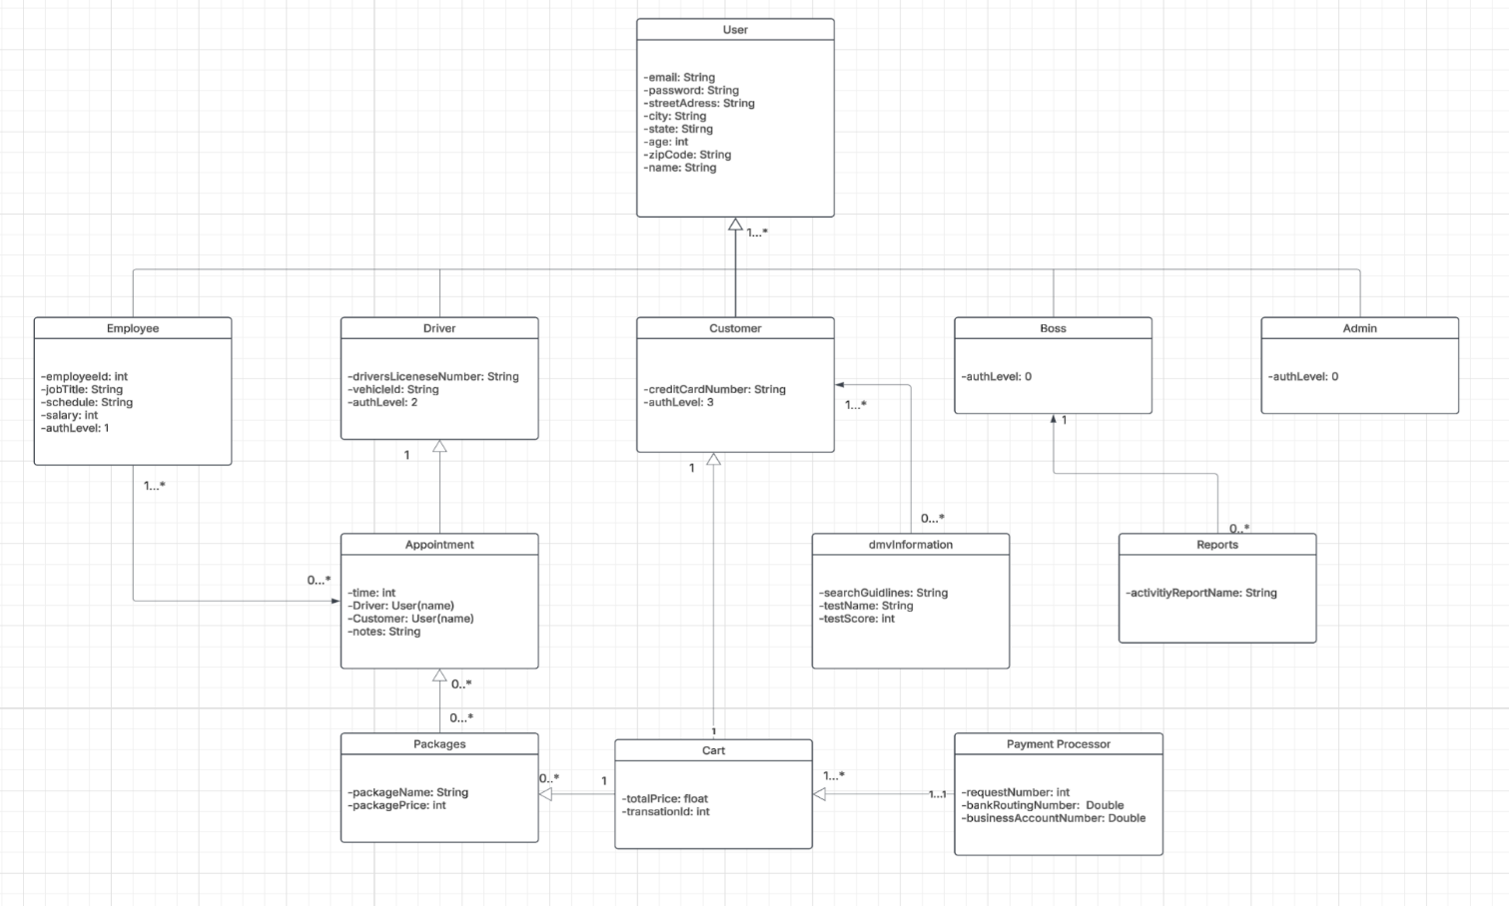

Technical Requirements
Hardware:
- Servers to hold information and run the system
- User devices such as phones, tablets, computers, etc.
- Networking equipment to get internet service

Software:
- Database to hold system information
- Programming languages for back-end development such as java or python
- Web-based frameworks for front-end development
- Mobile development languages
- Cloud services to run the system and transfer data

Tools:
- IDE’s like visual studios, eclipse or PyCharm
- Testing materials for unit testing on programs written
- Utilize a system to help manage control and inspire collaboration

Infrastructure:
- Implement strong security measures to keep information safe
- Backup data and keep it secure
- Make it easy for the program to grow
- Have it available for many different operating systems and platforms
- Keep track of activity on the system

